CSC1139/CSC1111 Mathematical Models/Computational Science
In-Class Exercise 4
AutoCorrelelograms
What do the following AutoCorrelation Functions Depict?

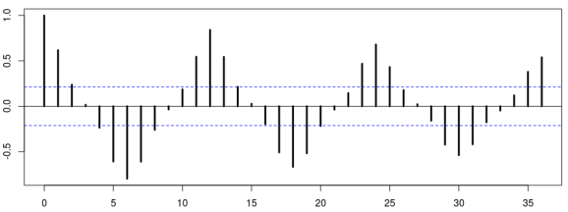

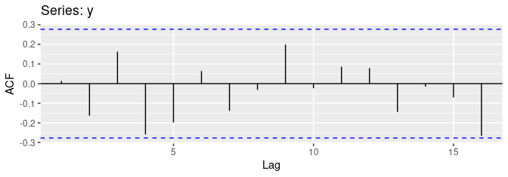

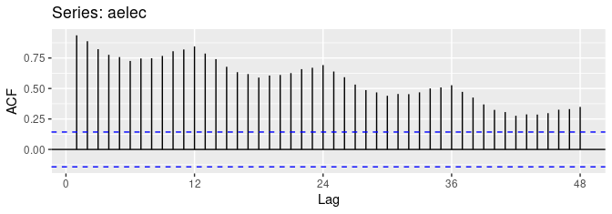
- What do you think the ACF of a Cyclical Time series would resemble?

- Exercise to fit a model to LA Heart Attack Data time series

- First download the cmort data from loop into the R working directory and then need to do: mort=scan("cmort.dat")
- Plot the data using the plot() function: plot(mort,type='l')
- Convert the data to a time series object using mort=ts(mort) (may need to use do library(stats)for this).
- Decide whether the series stationary is stationary or not:
  - First by eye-balling it
  - Then using the adf.test(mort) function in the notes (hint: need to call library(tseries).
  - Do you find the result of this test strange? There is certainly something counterintuitive: the plot looks trend-stationary (i.e. non-stationary) yet adf.test gives the result as stationary.
  - A better ADF test that doesn’t get mixed up with trends can be found in fUnitRoots (again,you might need to do library(fUnitRoots)
  - Now check out the stationarity results here for the cmort.dat: adfTest(mort)
  - If it isn’t stationary you can try taking first differences to do this you will need the function diff(mort,1)
  - Finally, you should do the ADF of the differenced series to check that it is stationary.
- Using PACF, estimate the order of the autoregressive model (p) that can be used to approximate the series
  - Note:
    - To get a better estimate load the stats package: library(stats),
    - Then lag.plot(mort,1)
- What you have done above is to take some data, remove the stationarity and fit an appropriate (here AR) model to it. This is the first step in building ARIMA models!

